Practical Number 9

Docker Volumes Demonstration

Part 1: Life Without Docker Volumes

Step 1.1 — Run a container without a volume

docker run -d --name mysql-no-volume -e MYSQL_ROOT_PASSWORD=root123 mysql:8.0

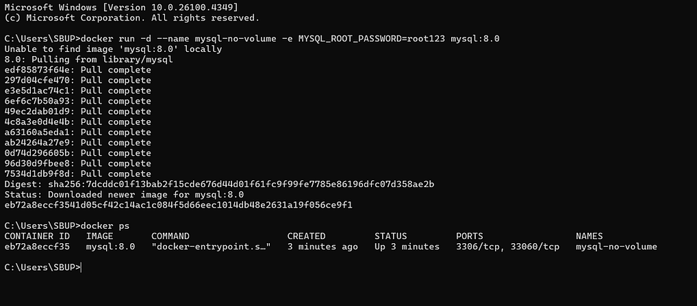

Step 1.2 — Connect and create some data

docker exec -it mysql-no-volume mysql -uroot -proot123

Inside the MySQL shell:

CREATE DATABASE testdb;
USE testdb;
CREATE TABLE users (id INT, name VARCHAR(50));
INSERT INTO users VALUES (1, 'Alice');
SELECT * FROM users;

Exit the shell:

EXIT;

Step 1.3 — Stop and remove the container

docker stop mysql-no-volume
docker rm mysql-no-volume

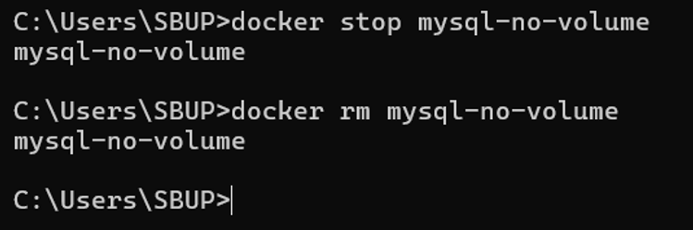

Step 1.4 — Recreate the container and check for data

docker run -d --name mysql-no-volume -e MYSQL_ROOT_PASSWORD=root123 mysql:8.0
docker exec -it mysql-no-volume mysql -uroot -proot123 -e "SHOW DATABASES;"
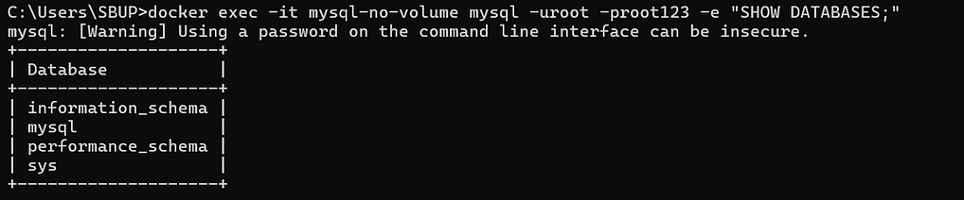

Part 2: Life With Docker Volumes
Now let's fix it using a named volume.

Step 2.1 — Create a named volume

docker volume create mysql-data

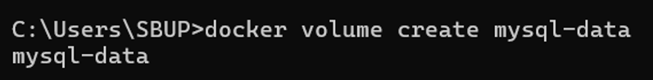

Verify it exists:

docker volume ls
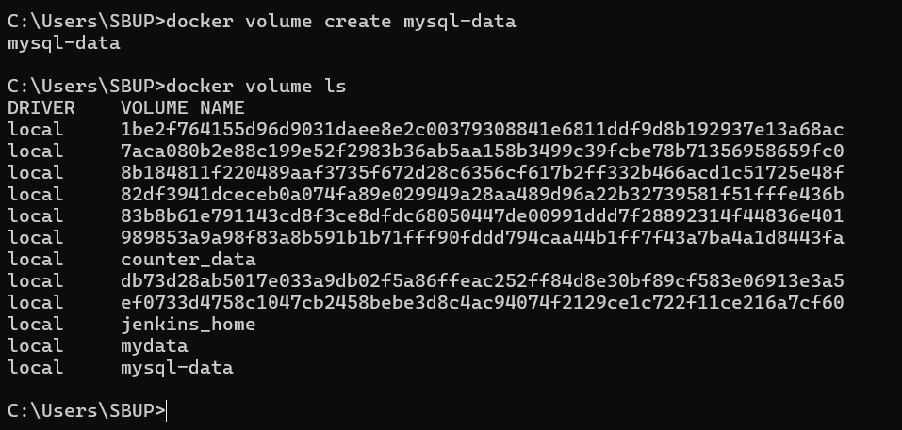

Step 2.2 — Run a container using that volume

docker run -d --name mysql-with-volume \
-e MYSQL_ROOT_PASSWORD=root123 \
-v mysql-data:/var/lib/mysql \
mysql:8.0

Step 2.3 — Create data again

docker exec -it mysql-with-volume mysql -uroot -proot123

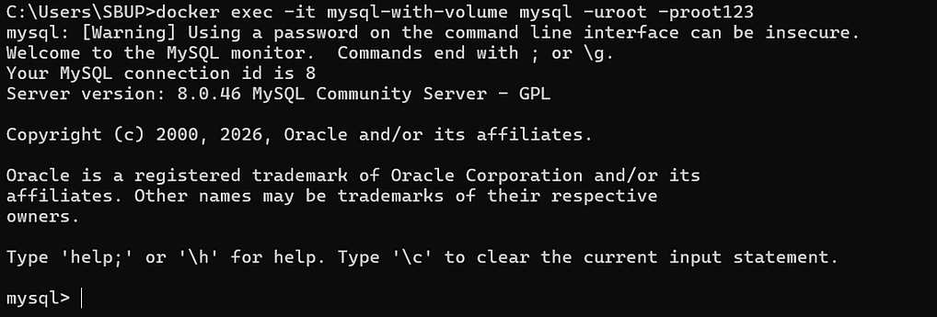

CREATE DATABASE testdb;
USE testdb;
CREATE TABLE users (id INT, name VARCHAR(50));
INSERT INTO users VALUES (1, 'Alice');
SELECT * FROM users;
EXIT;
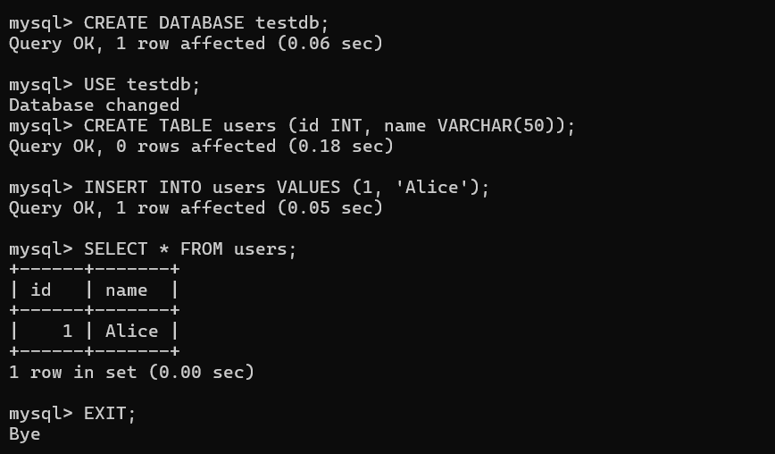

Step 2.4 — Destroy the container (but not the volume)

docker stop mysql-with-volume
docker rm mysql-with-volume
docker volume ls

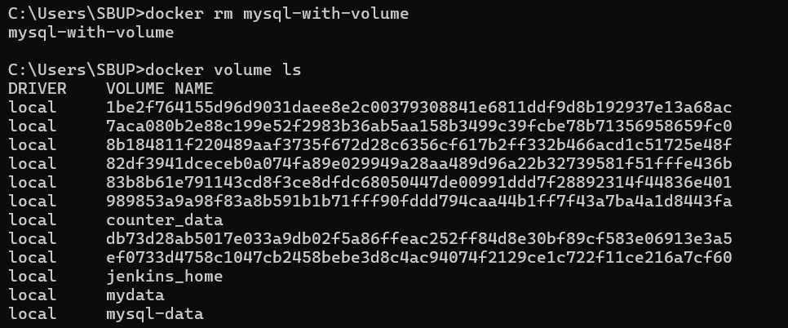

Step 2.5 — Recreate the container with the same volume

docker run -d --name mysql-with-volume \
-e MYSQL_ROOT_PASSWORD=root123 \
-v mysql-data:/var/lib/mysql \
mysql:8.0

docker exec -it mysql-with-volume mysql -uroot -proot123 -e "SHOW DATABASES; SELECT * FROM testdb.users;"

